19.24: For an ideal gas, 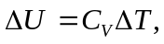 and at constant pressure, 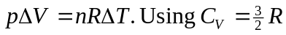 for a monatomic gas,

